Name:  Teacher : | ____________________________________  ______________________ |  | Date:_________
 | Year 10A  SCORE:  / 38  Mini Test 5  Topic – Bivariate Data  Full working out MUST be shown to get full marks for each question.
Total Time: | 40 minutes | 20 mnutes calc free , 20 minutes calc allowed.
Weighting: | 5%
Equipment: | To be provided by the student: Pen, pencil, ruler, scientific calculator, 1 single sided page of A4 notes

Q1) Describe the relationship for the following scatter graphs. [6 marks]

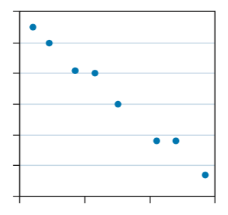
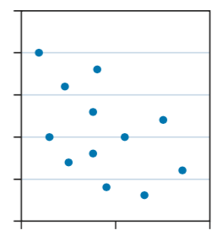

- _____________________________ b. __________________________
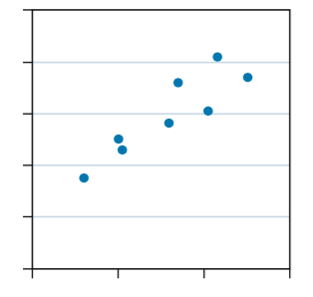

c. ____________________________

Q2) Using your knowledge of Bivariate data [1 + 2 = 3 marks]
- Define the term “Causal Relationship”

- Provide an example of a causal relationship and explain how it is causal.

Q3) Charley recorded her height from the time she was 12 to 17.
[2 + 1 + 1 +1 = 5 Marks]

Age (years) | 12 | 13 | 14 | 16 | 17
Height (cm) | 160 | 166 | 174 | 180 | 188

- Draw in a line of best fit, make a prediction about how tall she will be at 20 years old?

- Do you think that your prediction is accurate?

- What do you think would be a reasonable height for charley at 20 years old? Why?

- How tall was Charley at 15 years?

Q4) A statistician was asked to investigate whether countries with higher levels of consumption of a particular foodstuff tended to have a higher death rate due to heart disease. The following information was obtained for 12 countries. [4+1+2=7 Marks]
 | CONSUMPTION OF FOODSTUFF  kg per person per year | DEATHS DUES TO HEART DISEASE  Per year per 100 000 of population
Country A | 57 | 299
Country B | 13 | 154
Country C | 51 | 152
Country D | 48 | 295
Country E | 35 | 208
Country F | 9 | 100
Country G | 21 | 175
Country H | 10 | 120
Country I | 46 | 202
Country J | 64 | 290
Country K | 38 | 156
Country L | 29 | 250


- Draw a scatterplot on the axis below.

- Fit a trend line to the data

- Krystal says that a country where people eat 50kg’s of food would have 250,000 deaths in a year. Does this seem reasonable?

Calculator Allowed Section – 20 minutes Name ___________________________

Q5) Consider the variables x and y and the corresponding bivariate data.
[2+2+1+2+1+1=9 Marks]
x | 1 | 2 | 3 | 4 | 5 | 6 | 7 | 8
y | 2 | 3 | 3 | 5 | 4 | 7 | 6 | 7
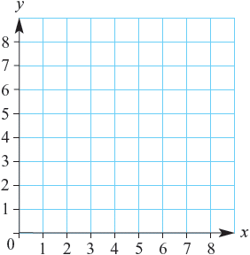
a Construct a scatter plot for the data.

b Describe the correlation between x and y?

_____________________________

c Fit a line of best fit by eye to the data
on the scatter plot.

d i Use a graphics or CAS calculator or software to find the equation of the
least squares regression line.

_________________________________________________________________

ii Estimate the value of y using the least squares regression line when x = 9.5.

_________________________________________________________________

iii Estimate the value of x using the least squares regression line when y = 7.8.
_________________________________________________________________

Q6) Usain Bolt of Jamaica successfully defended his title and set a new race record of 9.63 seconds in the 100m sprint in the London 2012 Olympic Games. Consider this record of winning times for the 100m sprint since 1952.
[4+2+2 = 8 marks]

Year | 1952 | 1956 | 1960 | 1964 | 1968 | 1972 | 1976 | 1980
Time | 10.79 | 10.62 | 10.32 | 10.06 | 9.95 | 10.14 | 10.06 | 10.25

Year | 1984 | 1988 | 1992 | 1996 | 2000 | 2004 | 2008 | 2012
Time | 9.99 | 9.92 | 9.96 | 9.84 | 9.87 | 9.85 | 9.69 | 9.63

- Draw a scatterplot of the data.
- Use your calculator to find the equation of the least squares regression line.

- In the 1960’s, the speculation was ‘When will the 10-second carrier be broken?’ Today, talks centre around ‘When will the 9.5 -second barrier be broken’ Use your equation to make a prediction when this might occur.

~END OF TEST~

